Your Olympus LUMPLFLN40XW is usable for fura ratiometric imaging but you will have to use a 360/380 nm ratio rather than 340/380 nm. The transmittance curve of your lens shows than at 340 nm transmittance is only 20% compared to 85% at 380 nm.

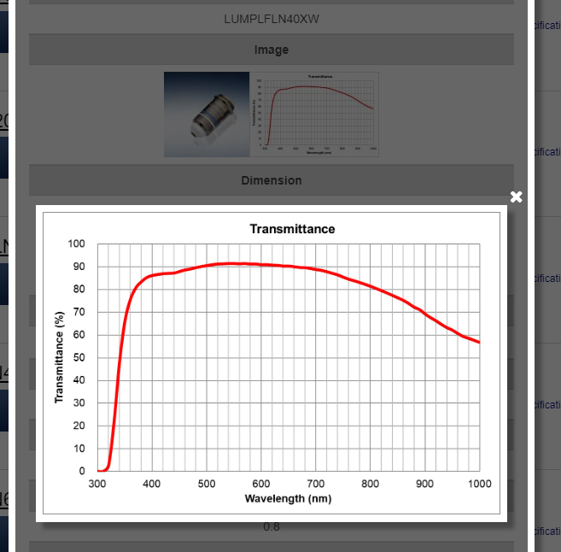

It might just be possible to create a usable 340/380 ratio by setting the CoolLED 340 nm illumination level to maximum but it would be better to use a 360/380 nm ratio since transmittance at 360 nm is 75%. The fura isosbestic point (where its fluorescence emission is insensitive to Ca) is close to 360 nm and this allows the 360/380 ratio to be used in the same manner as 340/380. The 360/380 ratio is smaller than 340/380 but it is still proportional to Ca.

To create 360/380 ratios you will need to replace the BP340/20 filter in your CoolLED (see below) with a BP 360/20, i.e. a bandpass filter centred on 360 nm with a 20 nm passband

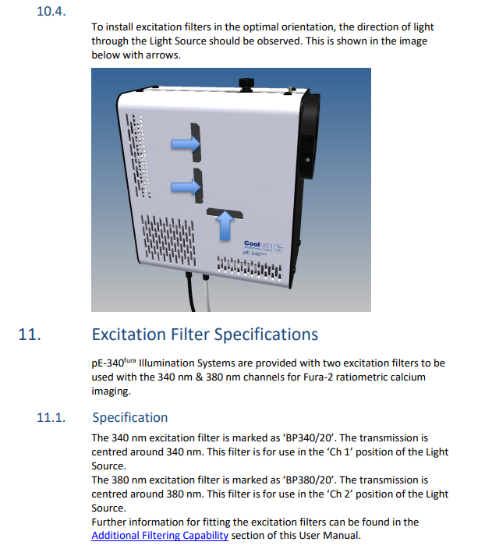

I think a Semrock FF01-360/23-25 filter might be suitable.

<https://www.idex-hs.com/store/product-detail/ff01_360_23_25/fl-004120?cat_id=products&node=individual_optical_filters>

but you might ask your CoolLED supplier for advice.

You will also need a suitable filter cube in your microscope. Normally it would have a 400 nm low pass and a 510/80 bandpass emission filter, e.g.

<https://www.chroma.com/products/sets/79001-et-fura-2>

The excitation filter would be removed from the cube since it is replaced by filters in the CoolLED.